TMT/Cherlapalli /S0560/2025 19.11.2025

To,
Venkatrao

Click to call: +91-8099666690 (verified)
Email: venkatrao.adisimilli@gmail.com (verified)
9/36/7, Cherlapalli, Secunderabad - 500083, Telangana, India

Dear sir,

Sub: - Supply of Roll Forming Machines.
TOP HAT PROFILE ROLL FORMING

S.NO | SCOPE OF SUPPLY | QTY
1 | Stands | 16passes
2 | Shafts Ø 50 | 32NOS
3 | Rollers hat- Section | 2Set
4 | Cutting Tool | 2Set
5 | Motor 20HP | 1Set
6 | Run of Table | 1NOS
7 | PLC HMI DRIVE | 1Set
8 | D Coiler 5Ton | 1Set
9 | Gear Box6” | 4NOs
10 | Cutting power Pack 7.5HP | 1Set
11 | 20Ton Cylinder | 1Set
12 | Machine Forming Bed(1+1) | 1Set
13 | Online Punching With 2kw Servo Motor | 1Set
14 | Punching Power Pack 10HP, With 3Cyliders | 1Set
15 | Punching Tools | 4 Sets
16 | Sheet Leveller With Gear Box & Motor | yes
17 | Lopping system Width 500mm,Depth 3mtrs | yes
18 | Entry Guide | 450mm length
19 | delivery Guide | turkstyle
20 | Servo Stands | na
21 | Section Size  (40 x height 40-120 mm x thickness upto 1.6 mm )
 | Price | 54,70,000=00

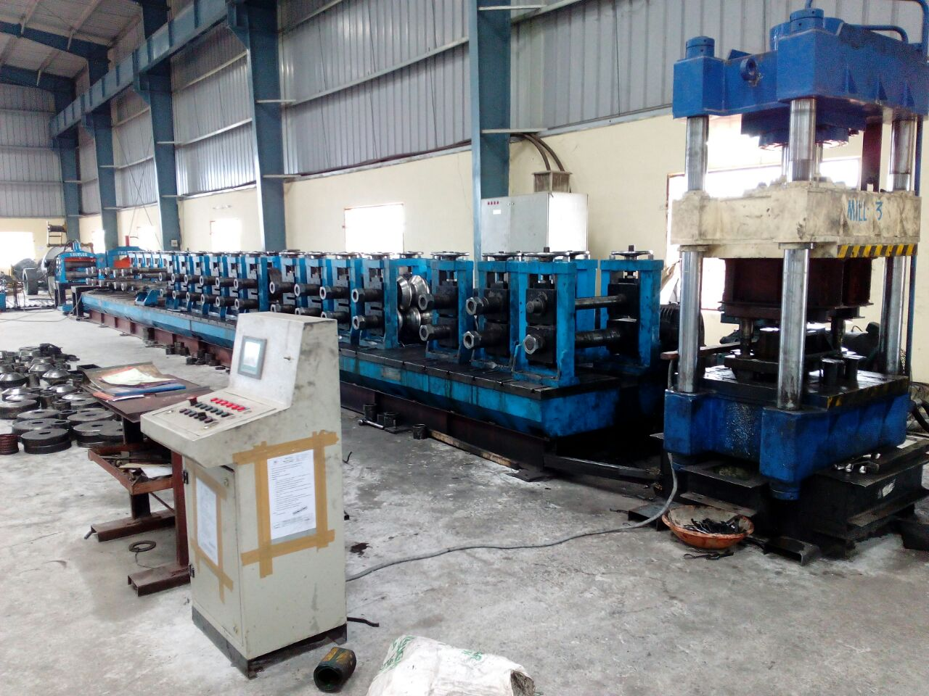

S.NO | SCOPE OF SUPPLY FOR C MACHINE | QTY
1 | Stands 60mm thickness | 14passes
2 | Shafts Ø 70 | 28NOs
3 | Roller C-Section | 1Set
4 | Cutting Tool (Any Size 3Ses) | 3Sets
5 | Motor 20HP | 3Sets
6 | Run Of Table | 2NOS
7 | PLC HMI DRIVE | 1Set
8 | D coiler 3Ton | 1Set
9 | Gear Box7” | 3NOs
10 | Cutting Power Pack12.5HP | 1Set
11 | 50 Ton Cylinder | 1Set
12 | Machine Forming Bed(1+1) | 1SET
13 | Online punching with5kw Servo Motor | 1Set
14 | Punching Power Pack 15HP, With 5Cylinders, oil Cooler | 1Set
15 | Punching Tools | 5Sets
16 | Section Size  (a)Web 50 to 250mm,  (b)Flange 40 to 80mm,  (C)Lip 10 to 25mm,Thickness 2.5mm
17 | Lopping System Width 500mm, Depth 3mtrs, Length4mtrs
18 | Sensors | 5Sets
19 | Servo Stand With Rollers 400mm Working Area | 1Set
 | Price | 46,90,000
“C” PURLIN PROFILE ROLL FORMING
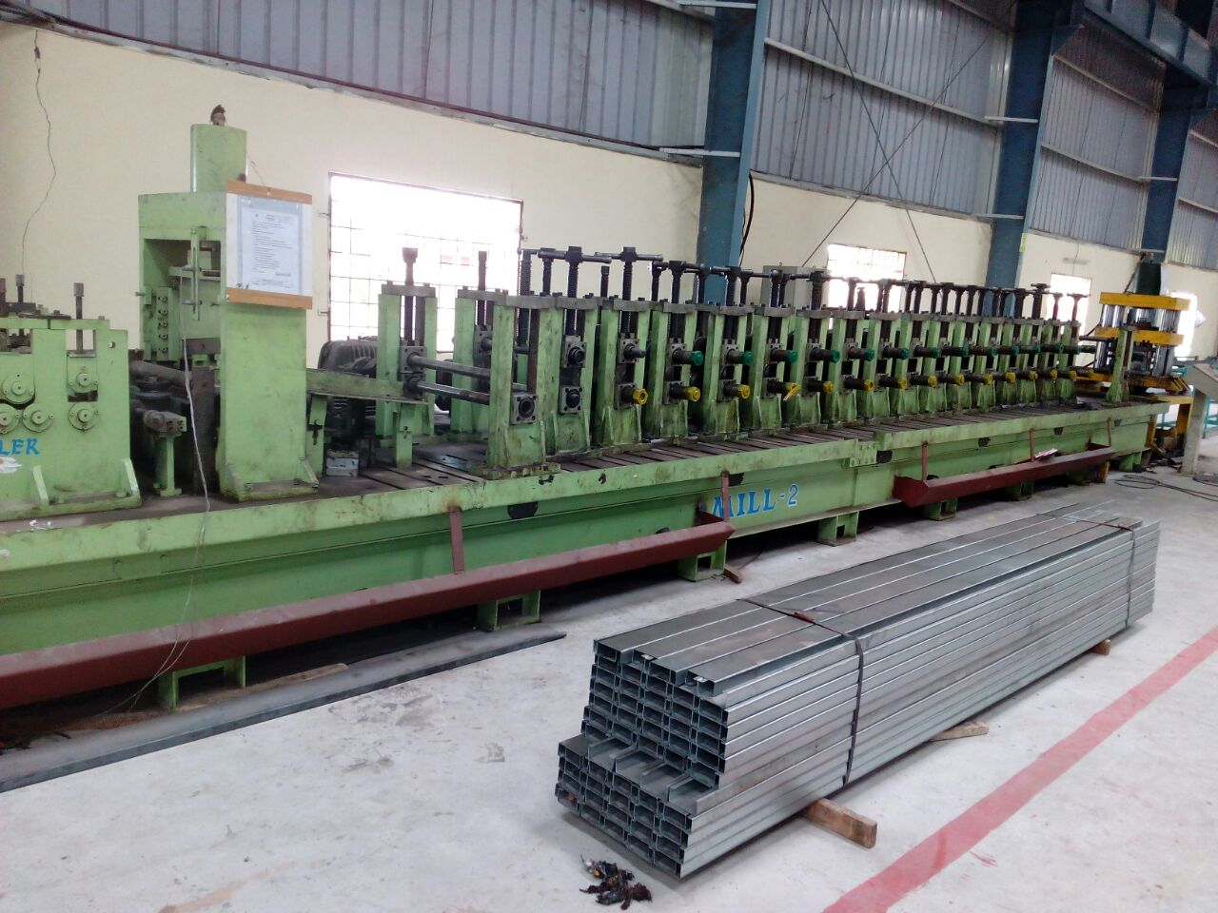

GENERAL TERMS & CONDITIONS:

- Price quoted per unit ex-work. Hyderabad.
- Following charges are additional to your account.
- Freight Charge : As actual to be borne by you.
- Sales Tax : 18% Extra as applicable
- Packing charge : As actual to be borne by you.
- Insurance : As actual to be borne by you.
- Payment : 50% advance along with order,
: balance 50% after installation and before delivery
- Delivery : within 8 weeks from date of advance received
- Validity : One month from the date of submission.
- Inspection : Inspection at our works prior to dispatch.
- Warranty : The machine is warranted for a period of 12 months from the date of dispatch against any manufacturing defects/ faulty material or bad workmanship of any part or component but not against any kind of abnormal or improper use of machine. Defective part or component will be replaced or repaired free of cost. Electrical components are outside the scope of this warranty.
- Commissioning : Erection & commissioning done by you, but required technical support & guidance provide by us at additional cost.

NOTE:
- Oil is not in scope of our supply.
- Raw material for trial is to be arranged by you at your cost.

We are sure you will find our offer in line with your requirements. Should you require any further clarification please contact T. Sivaramakrishna 9246221106. Email: techno9246221106@gmail.com WhatsApp No: 9849207176

Thanking you and assuring you of our best services.

For TECHNO MACHINE TOOLS

( T. SIVARAMAKRISHNA)

TMT/Cherlapalli /S0560/2025 19.11.2025

To,
Venkatrao

Click to call: +91-8099666690 (verified)
Email: venkatrao.adisimilli@gmail.com (verified)
9/36/7, Cherlapalli, Secunderabad - 500083, Telangana, India

Sir,

Subject : Design, Manufacturing, Supply, (including structure) of 10 Ton Cap gantry Crane - Reg.

1. Design, Fabrication, Supply and Erection of Per Set Rs. 23.50,000/-
10 ton EOT Crane as per following Specs.

General Specifications

- Type of Crane : Single Girder Electrically Operated Crane
Conforming to IS 3177 and 807
- Capacity of the gantry : 10 Tons

- Span of the gantry : 20 mts

- Lift of the gantry : 8.5 mts

- Type of Service : Indoor

- Class ( Mech / Elec ) : Class II

- Mode of Operation : Pendent Operated

- Type of Arrangement : Single Girder Box Type

- Ambient Temp. Considered : 45 Deg C



Lifting Equipment Specifications for 10 ton Unit

- Type of Hoist Proposed : 10 Ton Cap Wire Rope Hoist

- Type of Gear Box Casing Used : Totally Enclosed type Fabricated Stress
Relieved and Machined

- Material used for gears used in crane : Machine Cut Helical Gears Hardened
and Tempered
- Lubrication Provided for Gear Box : Splash Type Lubrication

- Bearing Used in the Gear Box : Self Aligned Anti Friction type Spherical
Roller Bearings
- Size and Make of Wire Rope : Dia 12 mm x 6/36 Const FM Core-Usha Martin

- Hoisting Speed : 3 mts/min

- Type of Hook : C type Hook conforming to IS 3815

- Class ( Mech / Elec ) : Class II

- Lift of the Hoist : 6 mts

- No. of Falls : 4 falls

- Rope Drum : Fabricated using Low Carbon Steel / Seam less
Pipe conforming to IS 2062 and duly stress relieved

- Motor Used : Sq Cage Induction Motor Crane duty– 6 pole
Class F/7.5 HP/40% CDF/150 Starts/hr -
BB/Siemens Make
- Type of Brake Used : EHT Brake– Dia 150 mm – 1 no of SOC Make

Type of Limit Switch Provided : Rotary Geared Type

Cross Travel Trolley

- Class of Duty ( Mech /Elec) : Class II

- No. Of Driver : 1 no

- C T speed : 12 mts/min

- Motor Used : Sq Cage Induction Motor Crane duty– 6 pole
Class F/2 HP/40% CDF/150 Starts/hr -
BB Make
- Type of Drive Proposed for Cross Travel : Floating Shaft Type Drive

- Wheel Housings used for CT : Bracket Type

Type of Limit Switch Provided : Shunt –2 Way Roller Leaver Type

- Specification of Wheels Used for CT : C 55 Mn 75 Forged Steel and Hardened to
30 HRC with diameter of 160 mm

Long Travel Trolley

- Class of Duty ( Mech /Elec) : Class II

- No. Of Driver : 1 no

- L T Speed : 15 mts/min

- Type of Drive Proposed for Long Travel : Twin Drive

- Motor Used : Sq Cage Induction Motor Crane duty– 6 pole
Class F/2 HP/40% CDF/150 Starts/hr -
BB Make

- Wheel Housings used for LT : Bracket Type

- Specification of Wheels Used for LT : C 55 Mn 75 Forged Steel and Hardened to
30 HRC with diameter of 300 mm

- Rail Size Considered for LT : 50 mm Sq Bar

Structure Considered for fabrication

- Platform : NA

- Girder for C T beam : Fabricated box type using M S plates

- End Carriages : Fabricated box type using M S Plates

- Type of Trail Cabling for Cross Travel : Through Flexible Trail Cabling

- Material used for Fabrication of crane : M S Conforming to IS 2062

- Painting Details : Two Coats of ROMP – two Coats
Enamel paint
- Safety features incorporated in system : Limit Switches for Hoist, LT, CT will be
provided

Electrical and Other Specifications

- Control Panel : Own make fabricated

- Cables used : Flexible copper cables
- Limit Switches : Reputed Makes will be used

2. Fabrication and Supply of Bus Bar Arrangement Rs. 1600/mt
for Electrical supply as per the Following Specs.

- Total Length of the Bus Bar : As Per Your Requirement

- Safe track type of enclosed Bus Bar : Safe track

- Capacity of the Bus Bar : 60 amps - GI

- Section used for the Bus Bar Brackets : Enclosed U type channel

EXCLUSIONS:

ALL CIVIL WORKS ARE NOT INTO OUR SCOPE OF SUPPLY
RAILS ARE NOT OUR SCOPE OF SUPPLY
ERRECTION EXTRA

GENERAL TERMS & CONDITIONS:

- Price quoted per unit ex-work. Hyderabad.
- Following charges are additional to your account.
- Freight Charge : As actual to be borne by you.
- Sales Tax : 18% Extra as applicable
- Packing charge : As actual to be borne by you.
- Insurance : As actual to be borne by you.
- Payment : 50% advance along with order balance before delivery but after inspection at our works.
- Delivery : with 50% advance with in 3 months.
- Validity : One month from the date of submission.
- Inspection : Inspection at our works prior to dispatch.
- Warranty : The machine is warranted for a period of 12 months from the date of dispatch against any manufacturing defects/faulty material or bad workmanship of any part or component but not against any kind of abnormal or improper use of machine. Defective part or component will be replaced or repaired free of cost. Electrical components are outside the scope of this warranty.
- Commissioning : Erection & commissioning done by you, but required technical support & guidance provide by us at additional cost.

NOTE:
- Oil is not in scope of our supply.
- Raw material for trial is to be arranged by you at your cost.

We are sure you will find our offer in line with your requirements. Should you require any further clarification please contact sivaramakrishna 9246221106.Email: md@technomachinetools.in
Thanking you and assuring you of our best services.

For Techno Machine Tools

T.SIVARAMAKRISHNA

TMT/Cherlapalli /S0560/2025 19.11.2025

To,
Venkatrao

Click to call: +91-8099666690 (verified)
Email: venkatrao.adisimilli@gmail.com (verified)
9/36/7, Cherlapalli, Secunderabad - 500083, Telangana, India

Dear sir,

Sub: - SUPPLY OF BRACE/SAG ANGLE 75X75 MM ROLL FORMING MACHINE

Thank you very much for your enquiry regarding your requirement of roll forming machine mainly for ANGLE Section. We are glad to inform you that we would be in a position to supply you the required equipment. Given below are the required specifications and description of the machine and our terms and conditions.

Prices

The cost of Roll forming machine with tooling for 75x75 Angle section along with de coiler, Entry guide, punching press, cutting press and cutting tool, delivery run out table along with drive system and Electrical panel with plc is RS 18,00,000/-(Eighteen Lakhs only).

LIST OT EQUIPMENT

- Manual DE COILER 3 MT CAPACITY
- ROLL FORMING MACHINE WITH 11 PASSES
- EN 31 MATERIAL TOOLING
- 7.5 HP DRIVE
- COMPLETE ELECTRICALS
- POST CUTTING PRESS WITH CUTTING TOOL
- Panel with plc
- Online punching press before forming

Technical specifications:

MANDREL UNCOILER

Model : Single arm

Coil weight : 3 MT Max

Material thickness : 1.2 – 3 MM

Coil width : 200 MM

Coil bore : dia 450 MM min, 550 MM max

Coil Od : 1500 MM (max)

Mandrel movement : Manual

Construction : M. S. Fabricated.

MAIN ROLL FORMING MILL

Maximum sheet width that can be formed : 250 MM

Maximum sheet thickness in MS that can be formed : 3.15 MM

Minimum sheet thickness in MS that can be formed : 1.0 MM

Roll shaft diameter : dia 60 MM

The vertical distance between shafts : 280 MM

The horizontal distance between shafts : 350 MM

Number of forming stations : 11 Nos

Drive (DC) : 7.5 HP

Speed of the machine : 12 meters/max

Description of the equipment

Roll Forming Machine

Main Base

The main base is MS fabricated structure and adequately ribbed to minimize the distortion. It is accurately machined on top and bottom surfaces the threaded holes are made on the bed for positioning the stands.

Entry Guide

The entry side of the machine will be equipped with guide table and the guide wheels bar which will be responsible for centering the leading ends of the strip into the first pass.

Roll shafts

The roll shafts will be manufactured from quality steel and will be keyed to locate tooling.

Drive

The drive to the roll former will be by means of a gear box system. The main drive will be provided by means of 7.5 HP motor. The speed of the roll former is variable.

Delivery runout table

The delivery runout table is with four meters length.

Cutoff unit

The cutoff unit with hydraulic press along with 1 cutting die sets will be placed in the machine delivery side.

Online punching press of 15 Ton and cutoff press of 30 ton

GENERAL TERMS & CONDITIONS:

- Price quoted per unit ex-work. Hyderabad.
- Following charges are additional to your account.
- Freight Charge : As actual to be borne by you.
- Sales Tax : 18% GST Extra as applicable
- Packing charge : As actual to be borne by you.
- Insurance : As actual to be borne by you.
- Payment : 60% advance along with order balance before delivery but after inspection at our works.
- Delivery : Within 3 months from date of advance received
- Validity : One month from the date of submission.
- Inspection : Inspection at our works prior to dispatch.
- Warranty : The machine is warranted for a period of 12 months from the date of dispatch against any manufacturing defects/ faulty material or bad workmanship of any part or component but not against any kind of abnormal or improper use of machine. Defective part or component will be replaced or repaired free of cost. Electrical components are outside the scope of this warranty.
- Commissioning : Erection & commissioning done by you, but required technical support & guidance provide by us at additional cost.

NOTE:
- Oil is not in scope of our supply.
- Raw material for trial is to be arranged by you at your cost.

We are sure you will find our offer in line with your requirements. Should you require any further clarification please contact t.sivaramakrishna 9246221106.
Email : techno9246221106@gmail.com

Thanking you and assuring you of our best services.

For TECHNO MACHINE TOOLS

(T.SIVARAMAKRISHNA)

